Class: 5/____  Student’s name: ____________________________ | REVIEW 1
I. Circle.
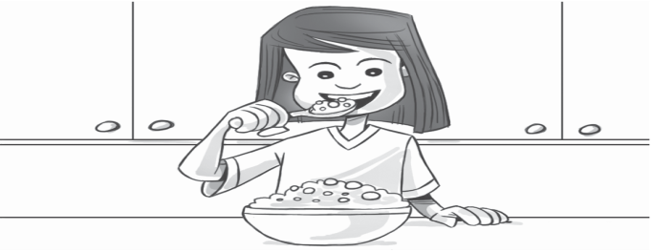  0.  have breakfast / get dressed | 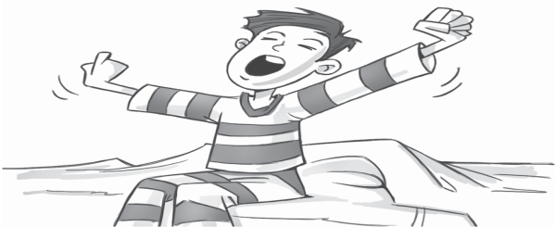  2.  get up / brush my teeth
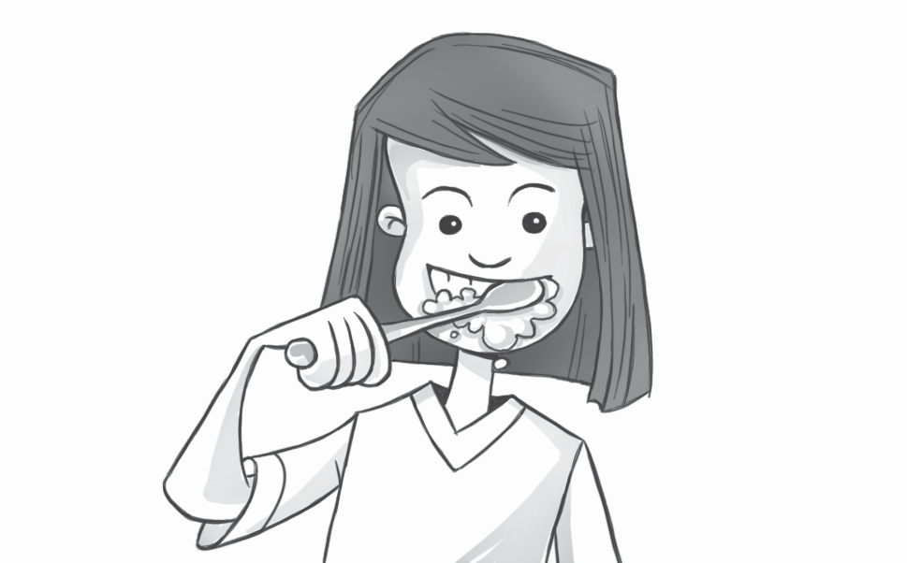  1.  have a shower / brush my teeth | 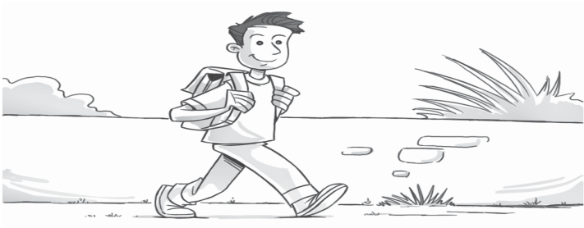  3.  catch the bus / walk to school
II. Complete.
every day First every day Finally Next

I get up at seven o’clock ⁰ every day . 1 , I have a shower. Then I
get dressed.2 ____________ , I brush my hair and have breakfast. 3__________________, I brush my teeth. Then I go to school. But I don’t go to school 4_______________.
III. Circle the correct words.
Tim What time do you / does you / you do get up on Saturdays?
Carl I get up / gets up / getting up at eight o’clock. But my brother Simon
get up / getting up / gets up at nine o’clock. He’s very lazy.
Tim Doing / Does / Do your friends go to the park on Saturdays?
Carl Yes, they don’t / do / does. We plays / playing / play soccer there. But my sister doesn’t / do / don’t come.
Tim What do / does / don’t she do?
Carl My mom and my sister does / do / don’t the food shopping together
on Saturdays.

