REVIEW 1

Trần Phú Primary School
Class:4/ _____
Student’s name: _______________________

1 Complete the words. | /3
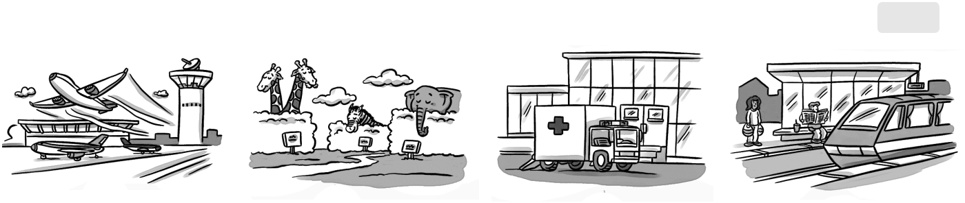

1 airport | 2 z |  | 3 h | 4 s
2 Circle the correct word. |  |  |  | /4
1 | 2 | 3 | 4 | 5
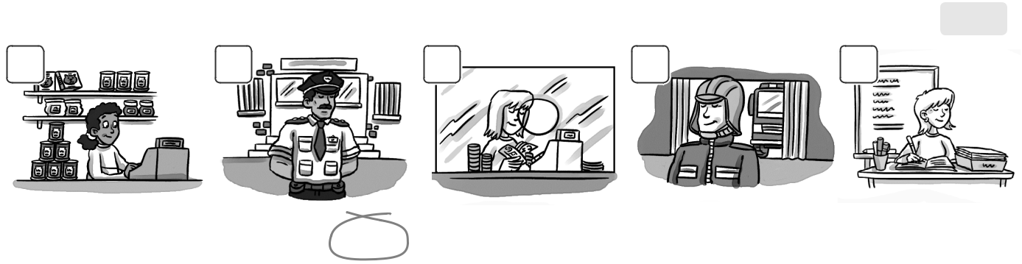

- She works in a zoo / store.

- She works in a bank / station.

- She works in a school / zoo.

- He works in a police station / hospital.

- He works in a store / fire station.

3 Complete the sentences and match. |  |  | /8
1 |  | a
Where does your dad work? |  |  | works in a store.
2 | your mom work | b
 |  | No, she | .
in a zoo?
3 | your brother | c
 |  | He | in a bank.
 | at an airport?
4 |  | d
Where | your |  | , he does.
sister work? |  |  | /15
