Tran Phu Primary school
Name: ................................................
Class: ................................................

EXERCISE 1 - GRADE 3

I. Write the words.
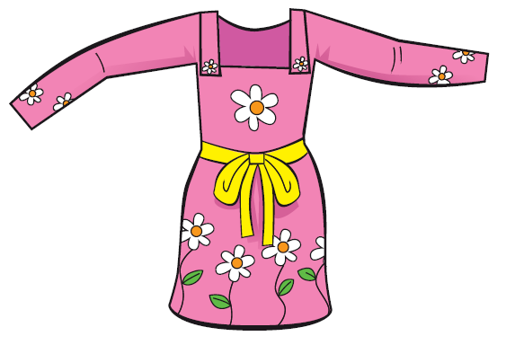
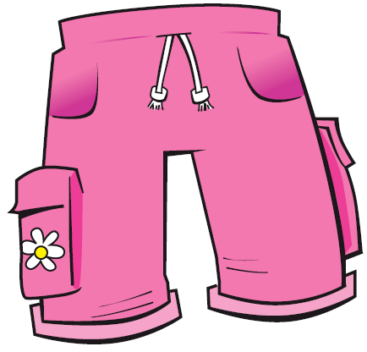

............................. .............................
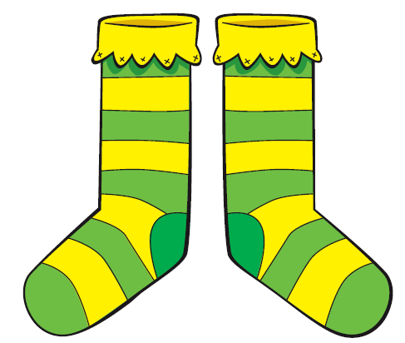
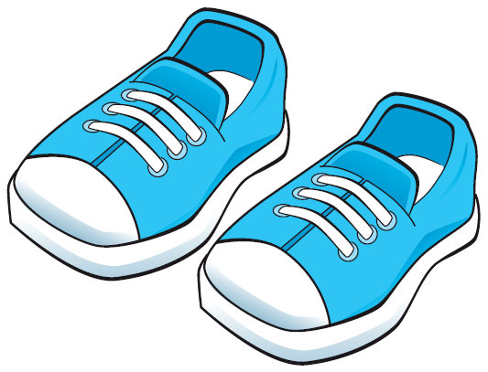

............................. .............................
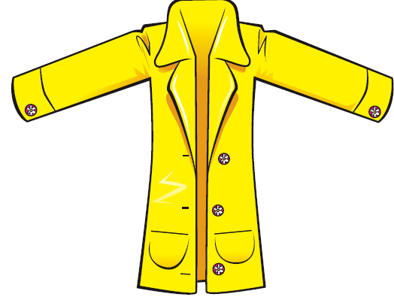
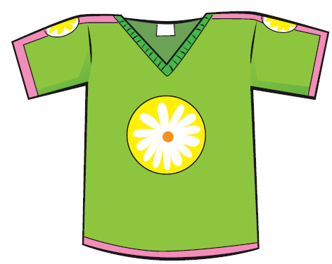
............................. .............................
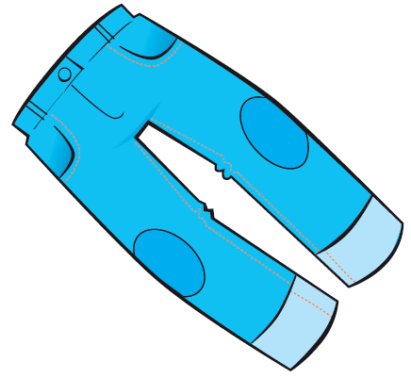


............................. .............................

II. Fill in the blanks.
- ................... is her dress.
- These .................... his socks.
- ............................ her shoes?
- Yes, .........................................
- ..................................... his pants?
- No, .........................................

III. Match.
* sheep
* box

sh
* sofa
* shoes
* fish

