Tran Phu Primary school
Name: ................................................
Class: ................................................

EXERCISE 1 - GRADE 1

I. Write. (Viết)

Hi. .......... ............ ............. ............ ............ ...........
Hello. ........... ........... ........... ........... ........... ...........

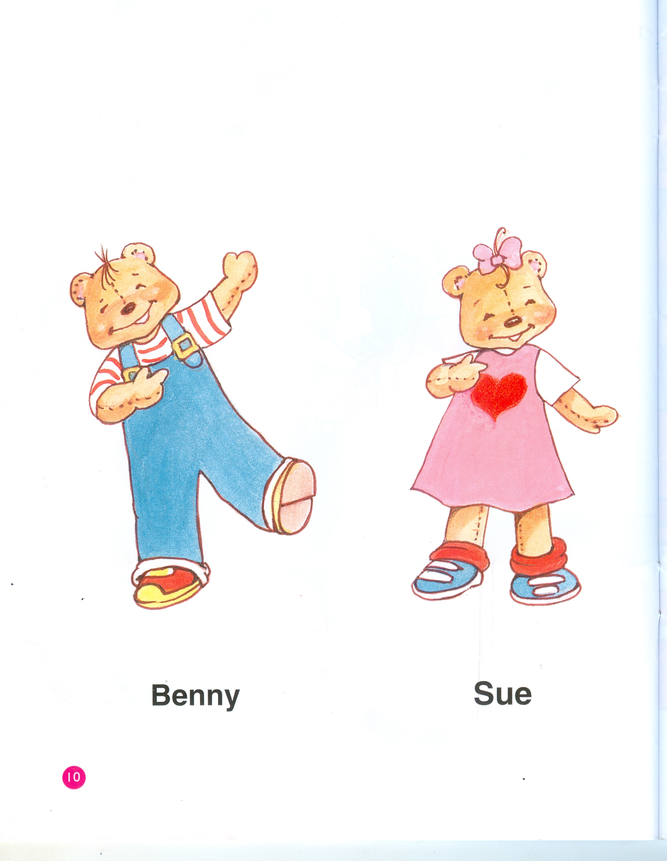
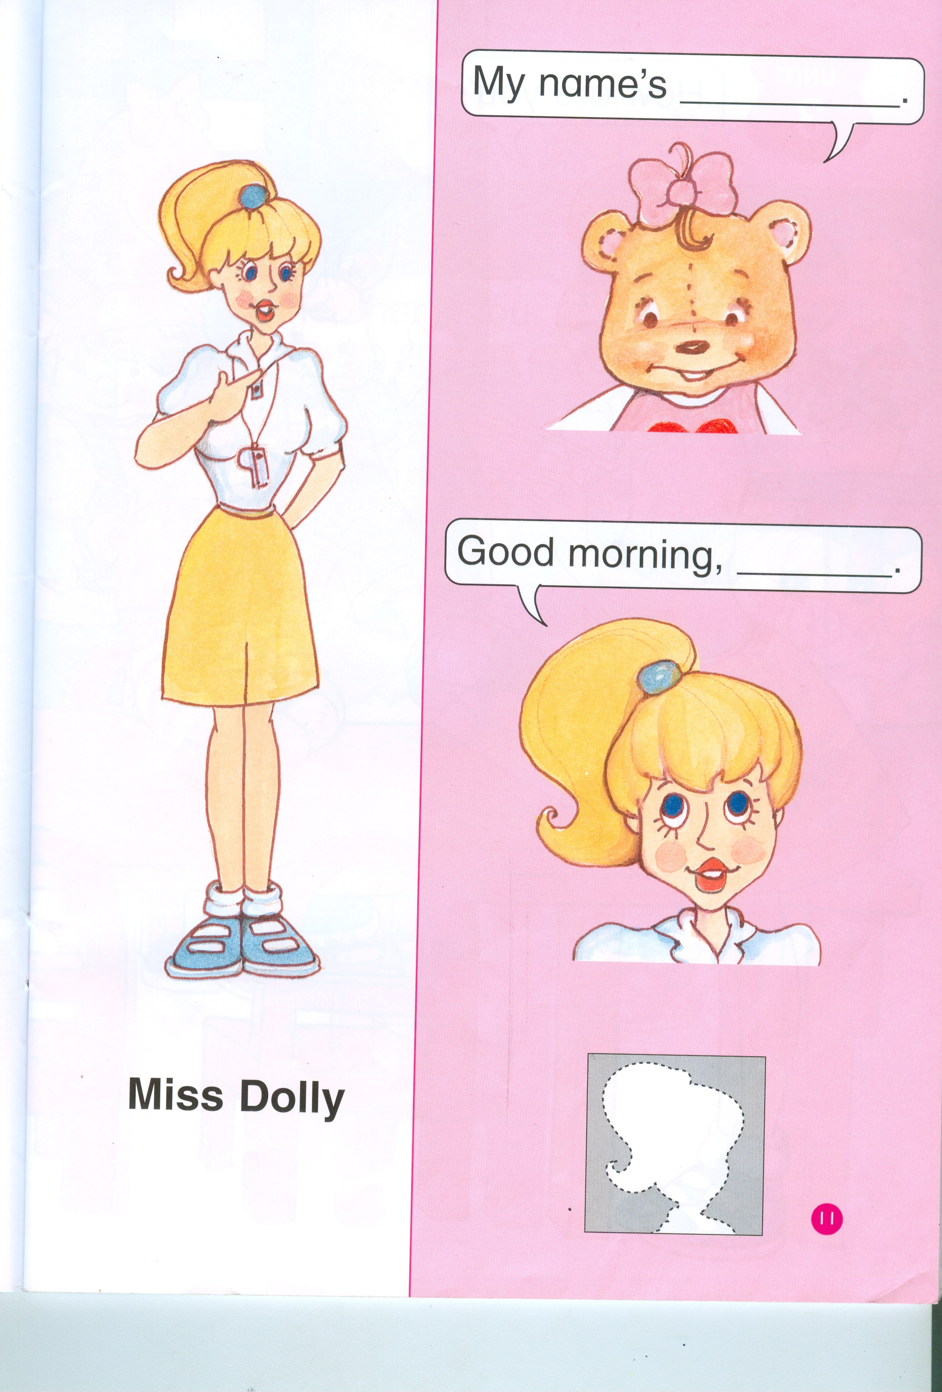
II. Match. (Nối)

* * *

Miss Dolly
Sue
Benny

III. Fill in the blanks. (Điền vào chỗ trống)

- I'm Benny.
- .............................., Benny.

- My name's Sue.
- Good .........................................., Sue.

