Tran Phu Primary school
Name: ................................................
Class: ................................................

EXERCISE 3 - GRADE 3

I. Write the words.

- .......................
2. .......................
3. .......................
4. .......................
5. .......................
6. .......................
7. .......................
8. .......................
9. .......................
10. ......................

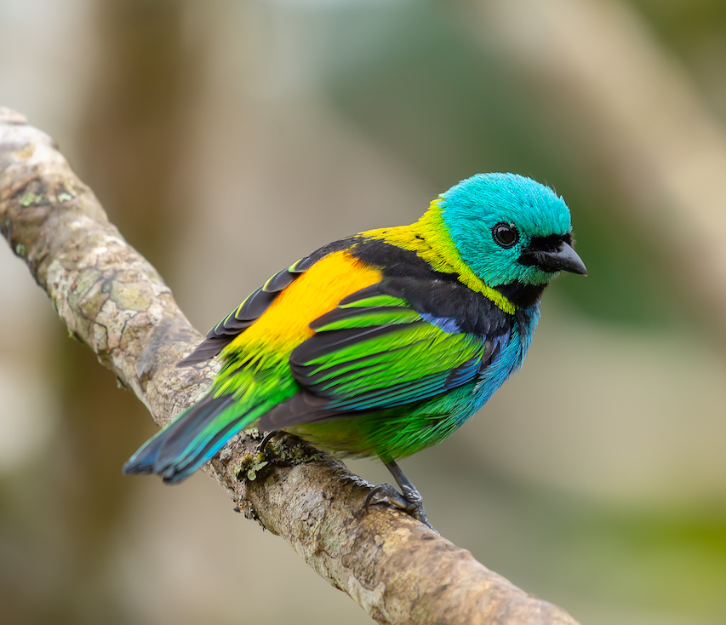
II. Fill in the blanks.
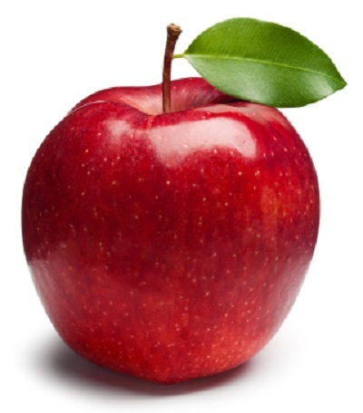
- What's .................. name?
- .................... name's Tim.

- How ................. are you? .....pple ....ird
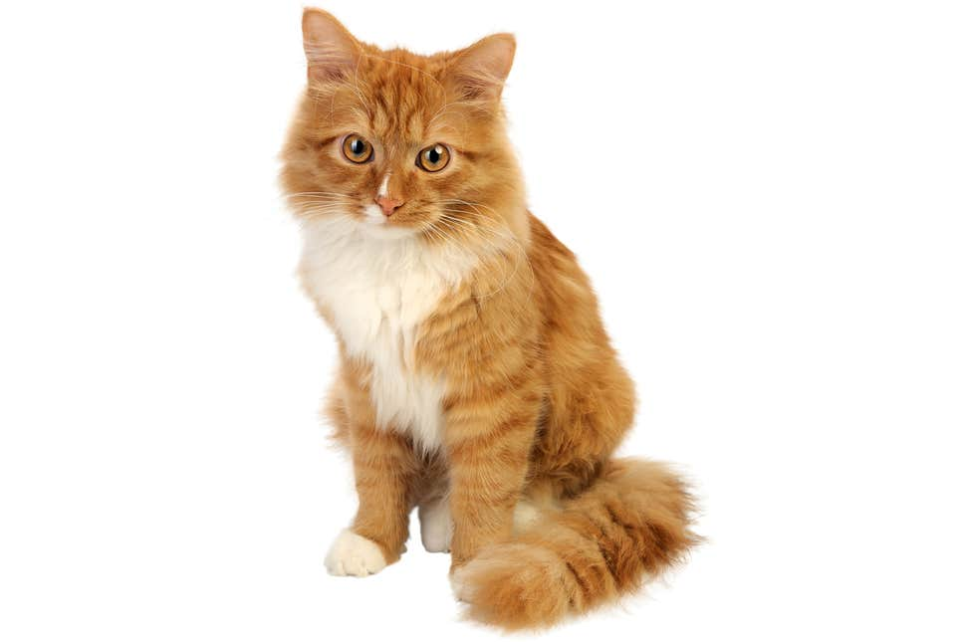
- .................. nine.
- .................... this?
- ...................... a pencil case. .....at ... og

III. Look at the pictures and write the words.
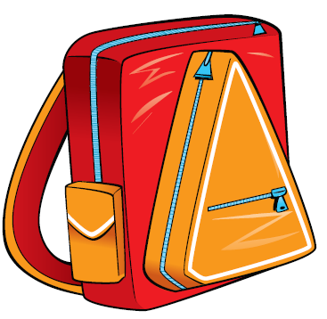
Hi, my name's Rosy. This is my ......................... .............................
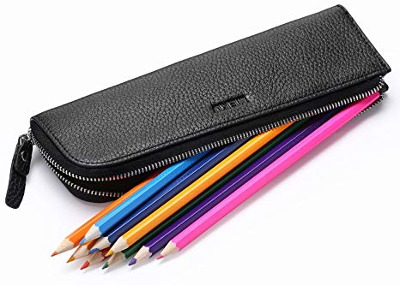
This is my ............................ It's blue and yellow. ............................
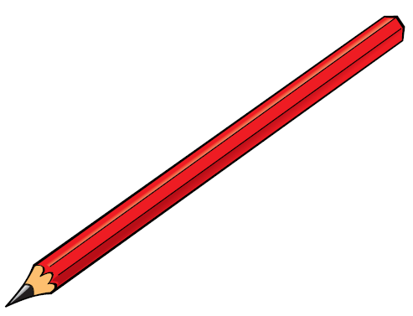
This is my green ........................ ............................
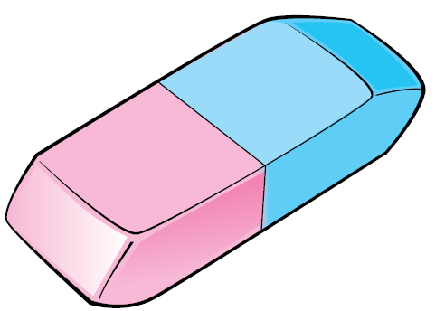
Look at this. It's ............................. .............................

