Class: 5/____  Student’s name: ____________________________ | REVIEW 3
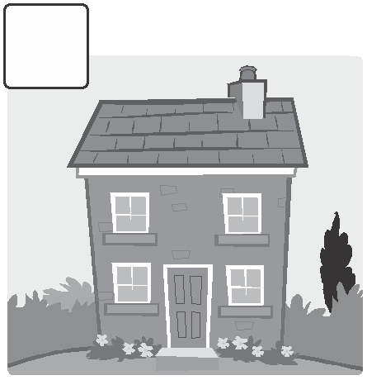
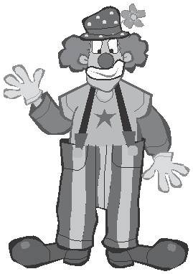
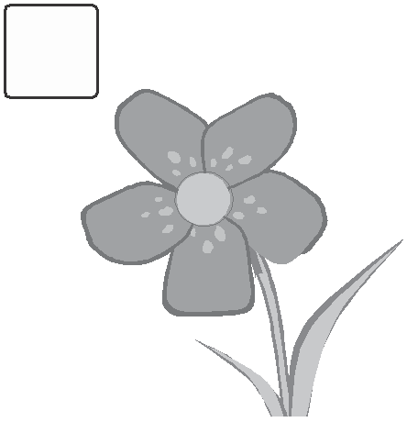
I. Write the words.
1 2 3 4 5
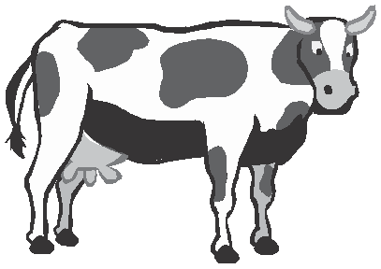
cow ________ __________ _________ ______________
II.Complete the words.

1 g e t dr e ssed 2 ave brea fast

3 c tch the b s 4 w lk to sc ool

III. Read and circle.

1 We has / have breakfast at eight o’clock.

2 My dad get / gets up at six o’clock.

3 He don’t / doesn’t catch the train to work.

4 Does she brushes / brush her teeth every morning?

5 I play / plays with my friends after school.

6 They don’t walks / walk to school.

7 What time does / do you start school?

8 Do / Does you have homework every day?

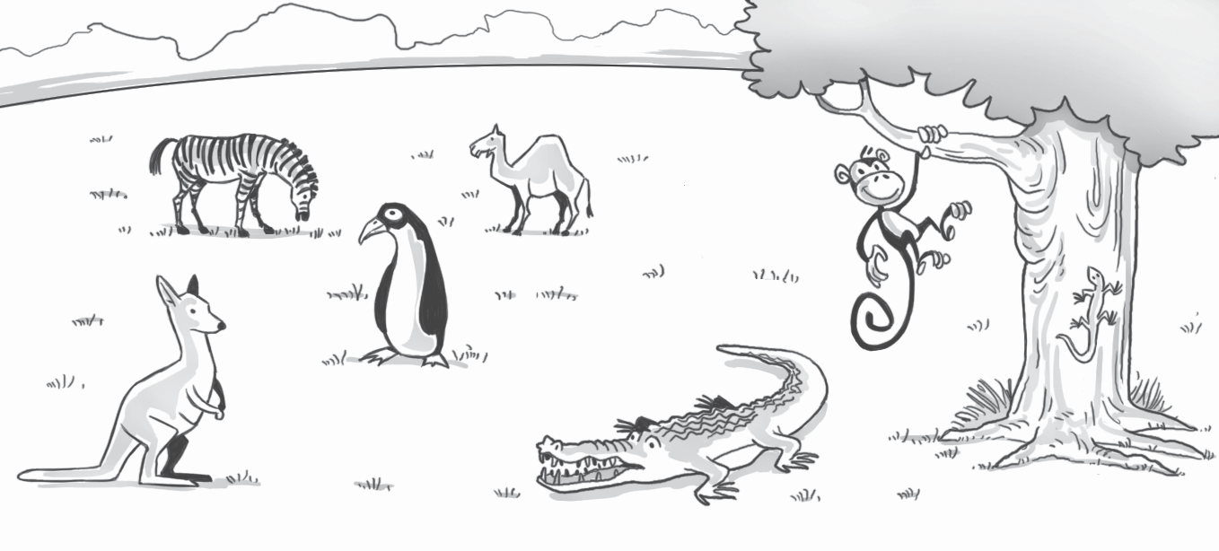
IV. Look and write.
3.
1. zebra
4.
2.
5.
6.
7.
monkey lizard
crocodile
zebra camel
kangaroo penguin

V. Match.
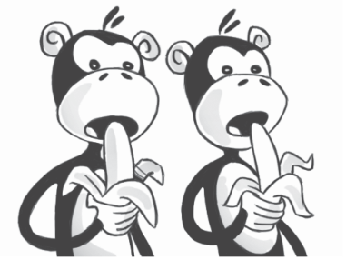
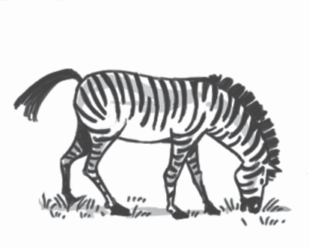
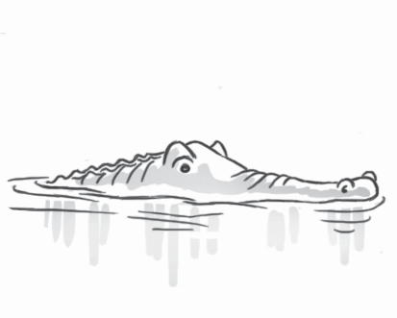
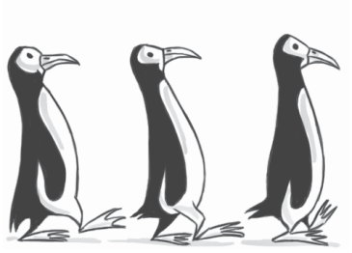
1 2 3 4

1 | Are the monkeys eating? | b | a | No, it isn’t.
2 | Is the zebra running? |  | b | Yes, they are.
3 | Is the crocodile swimming? |  | c | No, they aren’t.
4 | Are the penguins sleeping? |  | d | Yes, it is.

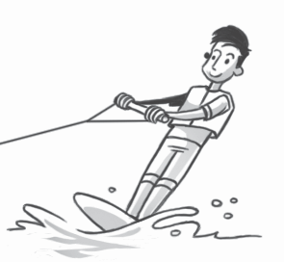
VI. Check () the correct sentence.
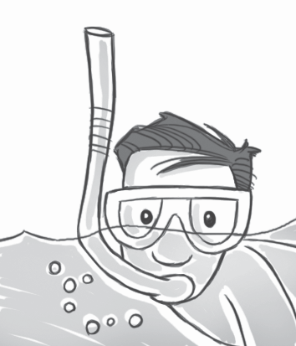
- 2

He’s snorkeling. He aren’t windsurfing.
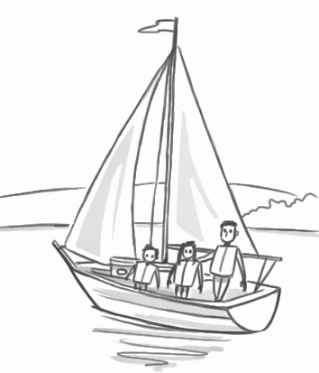
He’re snorkeling. He isn’t windsurfing.
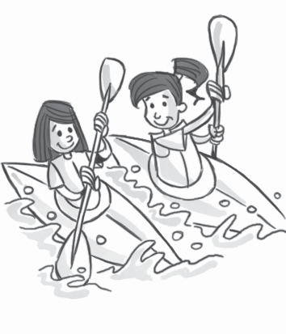
3 4

They’re kayaking. We’m sailing.
They’s kayaking. We’re sailing.

THE END

