NAME: __________________________
CLASS: _________

REVIEW 2
I. Choose the correct picture (chọn hình đúng với câu cho sẵn)
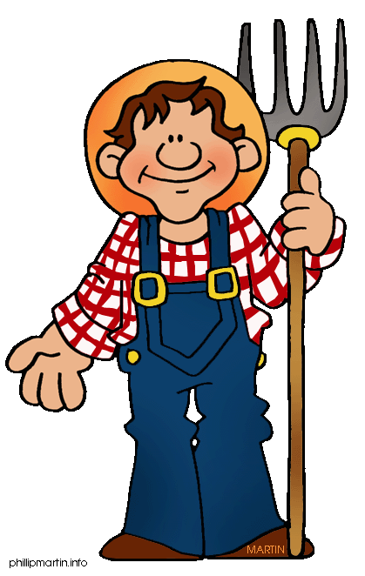
- He’s a farmer.
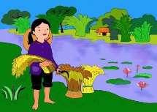
a. b c. d.

- That’s my pillow.
a. b. c. d.

II. Match (Nối)
1 .I’m hungry. | a. It’s snowing. | 1+..........
2. That’s my pillow. | b. Have some soup. | 2+..........
3. It’s sunny. | c. Good bye Sue. | 3+..........
4. I want candy. | d. No, It’s my pillow. | 4+.......
5. No! It’s my bear | e. I’m hot | 5+.........
6. I’m cold | f. shh! Be quiet | 6+..........
7. Good bye Benny | G Mmm! It’s good | 7+..........
8. Have some soup. | h. No,not today. | 8+..........

III. Fill the blank (điền từ thích hợp vào chổ trống):
Stop! raining some noodles want Go! bear police officer sunny

- Red light.__________________.
- Have ________________chicken.
- I ___________________ ice cream.
- Hurry up. It’s ______________________.
- I want _______________
- She’s a _____________________
- It’s __________________I’m hot

IV. Look, read and write into the sentence:( Nhìn, đọc và viết thành câu)
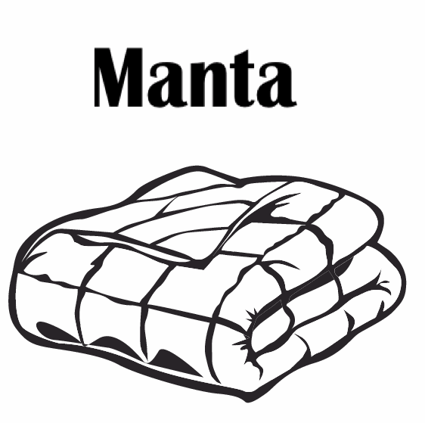 | Sue: That’s my blanket.  Benny : No, It’s my blanket.
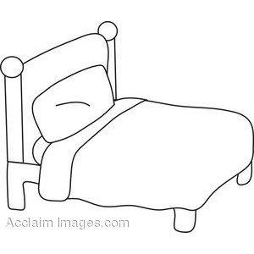 | Sue:_________________  Benny:_______________
Sue:_________________
Benny:_______________
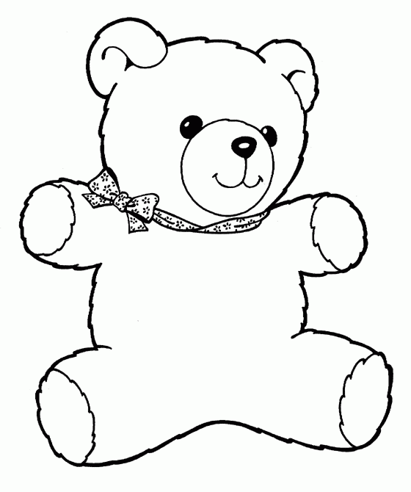 | Sue:_________________  Benny:_______________

V. Look and write the words (nhìn và viết lại)
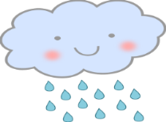
raining
 |  | 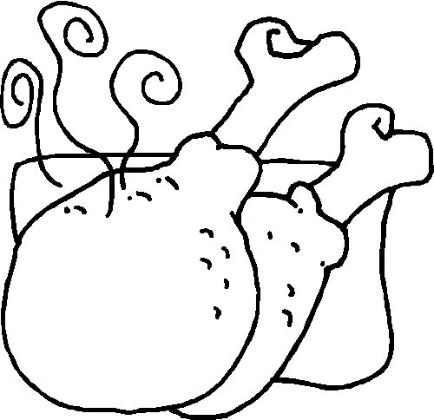 |  | 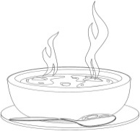
 |  |  | 